How to certify my Entlebucher for breeding
By Laureen Little, member of NEMDA and Health & Genetics Committee
The following article is my personal collation of basic information that may prove helpful to new aspiring breeders. The views expressed are my own and may not reflect those of NEMDA in general, the NEMDA BCOE, NEMDA’s Committees or members.
The Entlebucher Mountain Dog breed is one of the American Kennel Club’s (AKC) “Low-Entry” breeds, meaning that relatively few puppies are registered each year. Without dedicated owners stepping forward to breed responsibly, the future of our breed in North America could be at risk. Unfortunately, the situation is not much better in the breed’s native regions of Switzerland and Germany.
I encourage all Entlebucher owners to consider breeding their dog, at least once in their lifetime, contributing their unique collection of genes to the future of this wonderful breed. Dogs are physically mature at about 2 years of age and can be bred on the following heat cycle (or any other heat cycle until they are 8 years old). Breeding for the first time before 5 years of age is often encouraged, as younger dogs may adapt more easily to the physical demands of pregnancy and whelping. The National Entlebucher Mountain Dog Association (NEMDA) has developed resources to help new breeders get started. You can access those at this link; Nemda.org/Breeder-FAQ
Step 1: Is your dog a good breeding candidate?
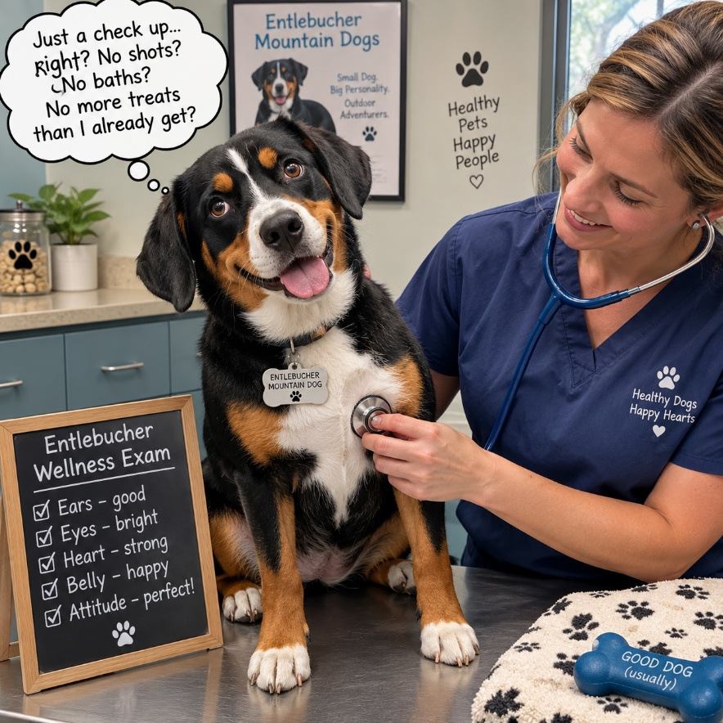
Health
Physically healthy
Good temperament
Appropriate body condition
Meets breed standard
How can you decide if you should breed your dog? Would breeding your dog benefit the overall breed? The following outlines the steps required to prepare your Entlebucher for breeding responsibly. You may want to learn more about the breed history, structure and temperament before you make your decision to breed.
First, you want to ensure that your dog is generally healthy, at an appropriate weight and of good temperament. Physical challenges can sometimes be inherited, and temperament matters just as much as appearance in future generations.
Bitches with significant anxiety may pass along a predisposition to anxious behaviour, making puppies more challenging to socialize successfully. Females that are overweight or underweight can have a difficult time conceiving, carrying a pregnancy and delivering puppies safely. Males may not produce enough sperm or be able to maintain a breeding tie. Your veterinarian can help you manage your dog’s diet and exercise to achieve healthy breeding weight and fitness over a few months. So, step one is a visit with your regular vet to discuss your dog’s health status and their breeding soundness.
Since you are considering breeding your Entlebucher Mountain Dog, your goal is to produce future generations of healthy, physically sound and temperamentally wonderful dogs. You have confirmed your dog’s health, so the next step is an evaluation of your dog’s physical stature compared to the breed standard. NEMDA, as the Entlebucher’s club in the USA, develops the breed standard, building off the original Swiss standard, now incorporated into the international Federation Cynologique Internationale (FCI) standard. You can access the breed standard here; https://nemda.org/Entlebucher-Breed-Standard. I have summarized key aspects of the standard below.
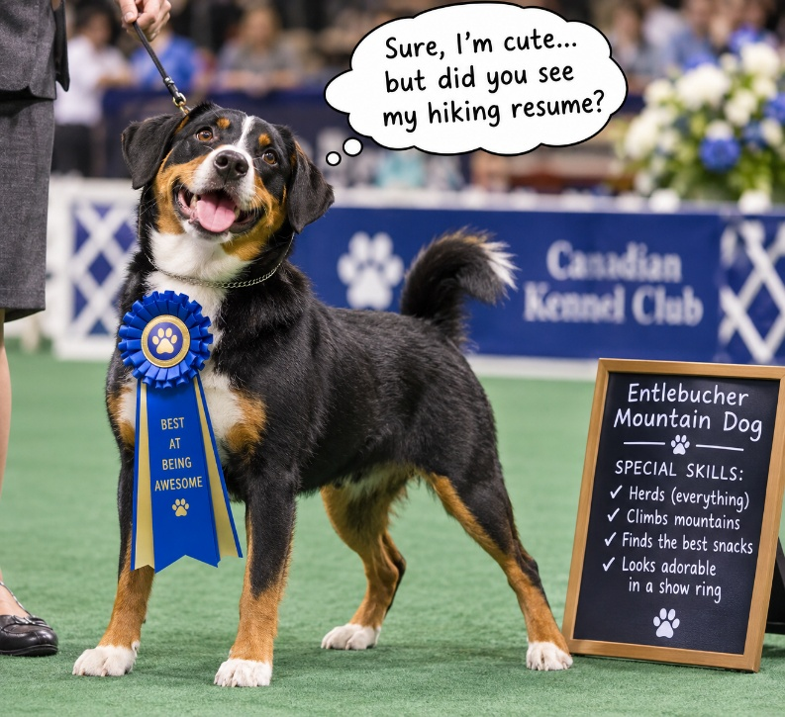
Simplified Breed Standard
Body height to length 8:10 ratio
Strongly muscled, agile, balanced
Forelegs short, sturdy, straight, parallel
Paws point forward, well arched toes
Colour – Black, white & tan to fawn
Markings symmetrical
White blaze and white from chin to chest
White on all four feet
Gait – ground covering, drive from rear
Head – slightly wedge shaped
Muzzle to skull 9:10 ratio
Expression alert, attentive, friendly

The physical evaluation of your dog in comparison to the breed standard requires a degree of familiarity with canine anatomy and movement. The following are options to assist you with this;
- Attend an International All Breed Canine Association (IABCA) show (www.iabca.com), where judges will identify the physical strengths and weaknesses of your dog.
- Participate in a Comprehensive Entlebucher Breed Assessment (CEBA) evaluation (https://nemda.org/ceba), which will provide an overview of both temperament and physical attributes of your dog.
- Ask your breeder to help with this assessment of physique and temperament.
- Your local dog training club will have someone that understands structure, gait and temperament to give you a first idea. Be sure to provide them with the NEMDA breed standard for reference.
When you read the breed standard, take note of a few defined terms. You will need to understand which deviations from the standard are considered disqualifications and those that are deemed faults or less desirable traits. A dog with disqualifying features will not be accepted into an AKC conformation event. Breeding of dogs with disqualifying features dilutes the gene pool with undesirable genes and should therefore be avoided. The purpose of the breed standard is to maintain the original appearance and functionality of the breed, a brave and agile cattle herder, devoted to his alpine herdsman. When considering why a trait has been deemed a disqualification vs fault or preference, consider the history and purpose of the breed. Lack of under-coat would make living in alpine conditions difficult while a curly tail might not present too many additional challenges as long as it didn’t get under the hooves of the cattle. Many herding breeds traditionally had bobbed tails or were docked for safety.

NEMDA Entlebucher Breed Standard | Disqualifying FAULTS
Height - M 17.5-20.5”, F 16.5”-19.5”  Body – strong and agile | Too tall or too short  Too heavy or light bone
Topcoat – short, harsh, shiny  Under-coat - dense | Absence of under-coat
Eyes - smaller, round, dark, with pigmented rims | Blue eyes  Yellow ‘hawk’ eyes
Jaw & Dentition - Scissor bite,  Even bite allowed | Over or Under shot Jaw  Wry mouth
Terms to Understand
Breed Standard
Fault vs. Preference
Disqualifying vs Desirable

Remember, there is no “PERFECT” dog. Every dog has strengths and weaknesses. When breeding, it is important to eliminate any heritable traits that are lethal, painful, or difficult to manage. Next, try to offset any “weakness” in your dog with a strength in that same area in the selected mate and avoid breeding two dogs with the same weakness or undesirable trait together.
Step 2: Complete the CHIC health testing for your dog
The Orthopedic Foundation for Animals, (OFA), provides a centralized database of all dog health testing in North America. Health tests which qualify a dog for breeding, under the breed club rules, are stored in the Canine Health Information Center, (CHIC), database. CHIC certification does not require the dog to be “perfect”, but it evaluates each known heritable disease and records the dog’s status for transparency.
As new genetic tests become available, NEMDA, as the breed club, may add them to the CHIC requirements, if the test can reliably predict disease before it produces symptoms. The current health testing requirements can always be found at OFA.org/chic-programs/browse-by-breed/?breed=EB.
If your Entlebucher meets the breed standard and is healthy and ready to breed, you should get them certified to breed by completing health testing. OFA has identified conditions which cause death, suffering or reduced quality of life, and are known to be heritable. Testing for these genetic markers before breeding can identify hidden health problems, which may never manifest with obvious symptoms in your dog, but still might be passed to offspring. Each disease is analyzed and advice is provided on when it is safe to breed, even with these identifying markers hiding in the background.
Most of the required health tests are ‘one time’ but an eye exam is required annually. The tests can be done in any order – I usually start with the least expensive, the microchip and DNA tests which are about $40 each and then the ACVO eye test. The eye exam, about $70, must be done by a qualified ophthalmologist and requires a special trip. Sometimes the eye exam is offered more economically at a dog show, so check that option. https://ofa.org/health-clinics-test/ The x-rays can be done at your regular vet’s office but may cost $500 or more.
What are the required health tests?
OFA requires that your dog have a unique identifying microchip. If your breeder didn’t already provide this, ask your vet to select a brand that meets the requirements for the American Kennel Club, (AKC) or Canadian Kennel Club (CKC).

NEMDA requires a DNA sample be included in the breed registry. This can be either a blood draw or cheek swab. Check the box for DNA Repository and print the submission form. https://ofa.org/applications/ You will receive a cheek swab kit in the mail with further instructions. These samples are used for genetic breed research.

For the genetic eye disease PRA-prcd, you need to get another cheek swab analyzed and then submit the results to OFA. Order a test at UCDavis.edu/test/pra-prcd, then use this form to submit the results to OFA https://ofa.org/applications/?form=DNA. This disease causes gradual blindness, but only if both breeding partners have the affected copy of the gene. Your test result will be either Type A - unaffected or Type B - carrier. By careful mate selection, BCOE breeders have eliminated Type C – affected dogs. We need all Entlebuchers that are qualified, to breed, so don’t worry if your dog is a carrier. Just be sure to always mate a carrier to a clear dog.
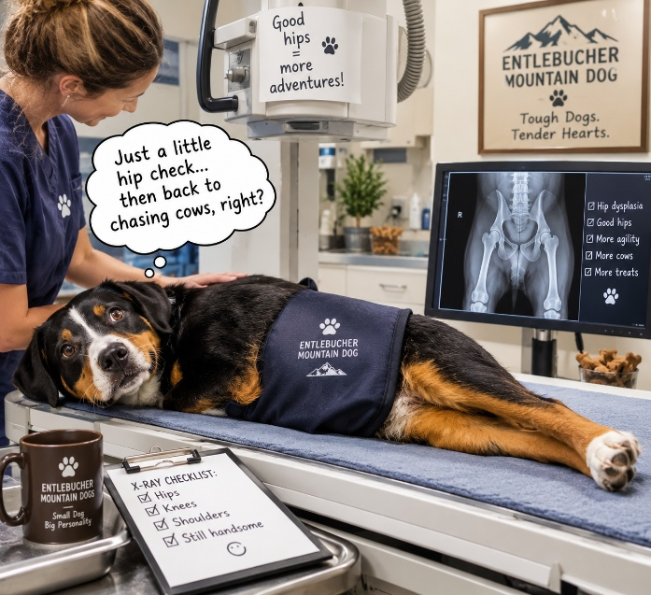
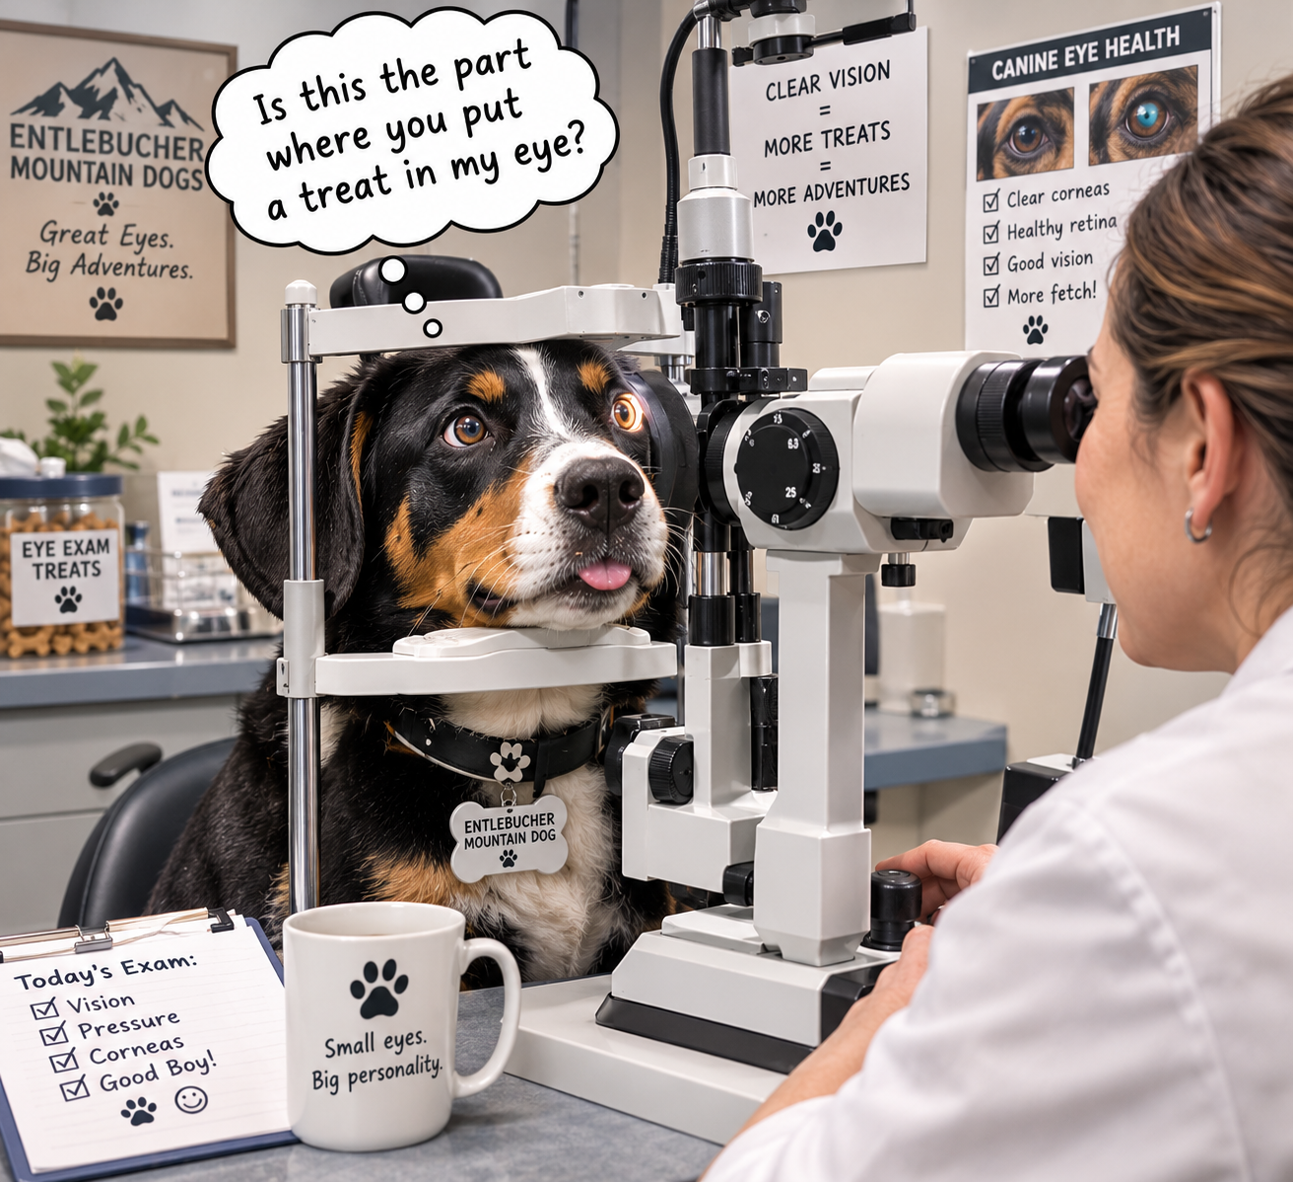
An eye exam is required within 12 months of breeding to screen for potential heritable eye conditions. Use https://www.acvo.org/ophthalmologist-search and type in your state and city. It will return a list of veterinarians that are able to perform the ACVO eye exam (previously called CAER). Make an appointment to have your dog’s eyes examined. These appointments can take some time to schedule, so don’t delay on this step. After the exam, make sure to submit the results to OFA, https://online.ofa.org/login/. Please check the box to include all results, regardless of outcome, in the public database.
Health Testing
- Microchip
- DNA sample
- PRA-prcd genetic test
- Hip xray
- Patellae exam
- Elbow – optional xray
- Annual eye exam
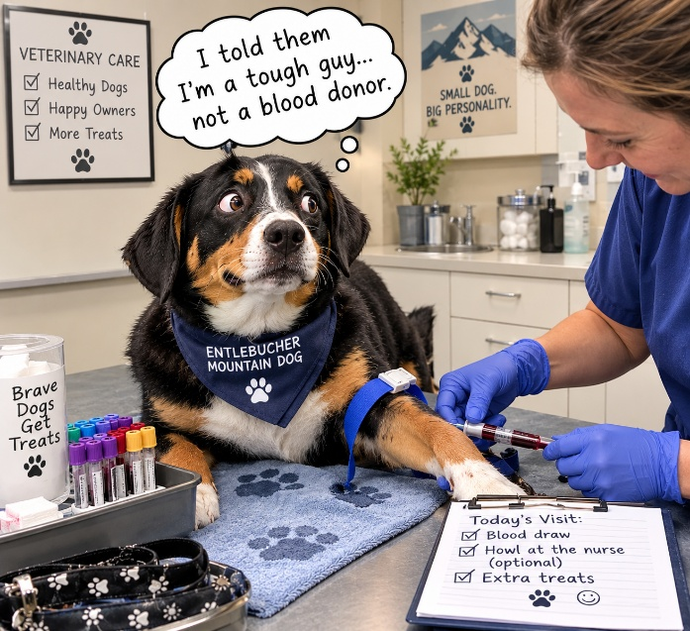

Entlebuchers, like most medium to large breed dogs, can suffer from hip dysplasia (HD). This disease starts with hip joints that are not structurally sound. Over time, with activity, the fit of the ball into the socket becomes looser and their gait is affected. This causes significant pain and poor quality of life. We know that dogs with good hips produce pups that have mostly good hips, so we test prospective parents to ensure that hips are well formed prior to breeding. OFA will score your dog as Excellent, Good, Fair, Mild Dysplasia, Moderate Dysplasia or Severe Dysplasia. If your dog ends up with a Fair score but is still qualified to breed, choose a mate with Excellent hips if possible. Careful selective breeding can improve hip scores over just a few generations.
For reference, here are examples of hip x-rays that were graded “Severe” and “Excellent” by OFA. Proper positioning is important for a good image, but the “balls” of good hips are tightly held within the “socket” even when the body is not completely aligned. Make sure your vet has done OFA Hip x-rays before and is familiar with the set-up. Most dogs require light sedation to hold the required position.
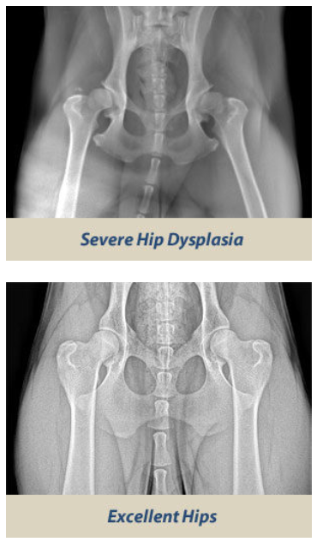
While you are doing the x-rays at your vet’s office, you can include the elbows, (ED), if desired, (not required). The exam for patellar luxation is required and can be completed by your regular vet. Patellar luxation, (PA), is a slipping kneecap which is also quite debilitating.
Once your x-rays and exam are complete, make sure to submit the files to OFA using the forms below.
Hip & Elbow Dysplasia – use the form at https://ofa.org/applications/?form=HE
Patellar Luxation – use the form at https://ofa.org/applications/?form=PA
Your x-rays will be evaluated by the team at OFA and you will receive their decision by mail. It will also be recorded in the database online, (be sure to check the box to record all results, regardless of outcome). If all the health tests are complete, you will also be issued a certificate and number for CHIC.
Congratulations! Your dog now has a CHIC number!
Every new and renewed CHIC certification is noted in the Entlebook each quarter, so look for your dog every year when you update your eye exam. We applaud owners for completing health testing as an important step in breed preservation.
When your CHIC certificate arrives, submit your results to NEMDA and update your dog’s information in the online pedigree database. https://nemda.org/Pedigree-Database. The database allows other breeders to see that your dog has the necessary tests for breeding.
It is important to note that a CHIC number certifies that testing was completed. It does not indicate whether results meet the recommended breeding criteria. Always check the actual test results and the requirements for breeding. For instance, NEMDA permits a ‘Fair’ score on HD for breeding but even a score of ‘Severe’ will receive a CHIC number. It is recommended that you learn about each disease and its inheritance patterns.
What scores are approved for breeding?
NEMDA, as the Entlebucher Breed Club in the USA, provides recommendations on breeding. They recommend only breeders who have agreed to their Breeder Code of Ethics (BCOE), which can be found here; https://nemda.org/Breeder-FAQ#member. If you agree to follow their rules, you can join the BCOE as follows; https://nemda.org/BCOE-Breeder-Application.
Health testing often has age requirements and sometimes limitations based on the score. To be compliant with NEMDA BCOE breeding requirements, the following health test scores are currently required;
NEMDA Required Health Testing Scores for Breeding
Excerpt from BCOE revised 07/15/25

OFA Hip Rating/Certification
Hips radiographed and certified by the OFA as Fair, Good, or Excellent after 24 months of age.
Patellar Rating/Certification
Patellae examined and certified by OFA as Normal, Grade 1, or Grade 2 after 12 months of age.
A dog with a Grade of 1 or Grade 2 may only be bred to a dog that is certified Normal
Annual Eye Certification
Within 12 months of breeding, eyes examined by a board certified ACVO Ophthalmologist and certified free from inherited eye disease
Progressive Retinal Atrophy (PRA)
Prior to breeding, a DNA based prcd-PRA test completed and certified through OFA.
Dogs certified ‘Affected’ should only be bred to dogs certified ‘Normal’.
Dogs certified ‘Carrier’ must be bred only to dogs who are ‘Normal’.
Dogs certified ‘Normal’ can be bred to any qualified dog.

Breeder Option: Some health tests may return results that indicate a heritable condition that can still be bred, depending on the breeder’s own criteria.
Breeding Responsibly
Breeding your dog responsibly will require a significant amount of your time and attention. Breeding and whelping will involve late nights, lots of cleaning and numerous visits to your veterinarian. It will require ongoing education and special purchases, just for breeding and whelping. Finding good homes for puppies can take a lot of time and effort. And breeding includes its share of heart ache. We encourage you to breed your Entlebucher, but we want you to be prepared and thoughtful in your planning.
Certifying your dog to breed is a big step. There will be lots more to learn before you welcome your first puppies, but you are on your way. Consider joining Good Dog Breeders https://www.gooddog.com/#direct_signup=breeder-sign-up to access some excellent educational materials for dog breeders. Formerly known as AVIDog, Gail Watkins created these materials to provide prospective breeders with the knowledge and confidence to breed their dog successfully. AKC and CKC also offer breeder seminars periodically and the NEMDA BCOE can help with educational materials and ideas.
Personally, I would not accept a puppy intended for future breeding, if it did not have a DNA test showing either Normal or Carrier status from OFA on the PRA-prcd test. Afterall, this test can be completed as a cheek swab on pups at just one week old, with results back in time for the 8 week pick up. As a responsible breeder, you will develop your own ‘rules’ for what you deem acceptable in breeding stock and puppies going to ‘breeder’ homes. Where it is of minimal cost and time delay, I prefer to know as much about the future health of a puppy as possible, before it is considered for breeding. Decisions like this will become part of your personal Breeder Philosophy, your blueprint for how you plan to contribute to the preservation and betterment of this wonderful breed.
As you contemplate your future as a valued breeder of Entlebuchers, take a moment to write out your goals and strategy. You can revisit this document and improve on it at any time, but even a first draft will give you a start to some deep thinking about your objectives and desires for the breed. What is important to you in the dogs you will breed? How do you plan to operate your breeding kennel? How will you interact with the breed club? How will you stay abreast of advancements in science and breeding knowledge to provide the best care possible for your dogs and puppies? Who are your anticipated puppy buyers? How will you find good homes for the puppies? Who can help you in any stage of the breeding process? Be practical about the help that you may (or may not) have available from family and friends. Be creative about finding others who can support you and your dreams.
Of course, your philosophy, goals and strategy will reflect your personal relationship with your dog and the breed. Over time, you will learn and grow as a breeder and incorporate new ideas into your practices. Wherever you are on your breeder journey, I appreciate your efforts to support our wonderful breed in a bright and healthy future.
Stay tuned to the NEMDA webpage and any communications they may send. They provide some excellent educational materials and an opportunity to become familiar with the breed, its history and its current champions.
Good luck in your breeder journey and …

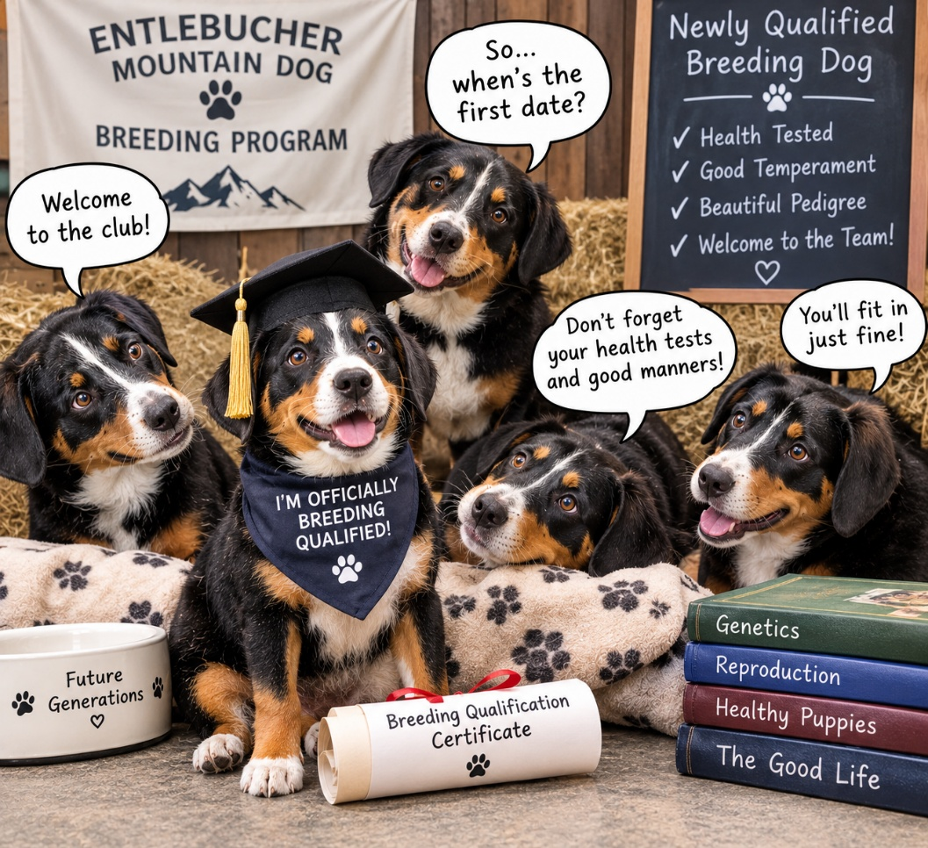
Welcome to the pack!

